Filter Keys

Usually, if a keyboard randomly stops working, it's most often something called **Filter Keys**. After holding down a key for so long, a box will pop up asking if you wish to enable filter keys. Often, most people are still typing when it pops up, so it doesn't stay up for very long. This can be rectified by going into the control panel:

1. Press **Start** and load up the menu. Once it loads up, type "filter keys" into the search bar, and click on **Ignore repeated keystrokes using FilterKeys**.   
   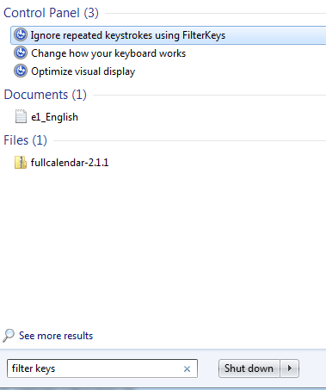
2. Make sure that **Turn on Filter Keys** is turned off. Next, there should be an option underneath that one that reads **Turn on Filter Keys when right SHIFT is pressed for 8 seconds** - make sure that checkbox is also turned off.   
   